Practice Questions

Question 1
Create a Finite automata of the following game of snakes and ladders, the input will be from a number between 1 and 6.
Clearly define, States, Final States, Initial State and Transitions.
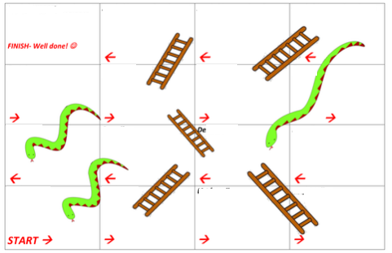
Question 2:
Draw a FA for the following languages
- Language of Strings that are valid email address of Fast university student
- Languages that are valid identifier of Python language
Question 3
For languages L1 to L10 over alphabets {a, b} do the following
- Enumerate some elements
- Draw a Deterministic Finite Automata

- L1: The language of all strings containing even number of a’s and each a is followed by at least one b.
- L2: The language that has even length and odd number of a’s.
- L3: The language of all strings in which every pair of adjacent b’s appear before any pair of adjacent a’s.
- L4: The language of all strings containing no more than one occurrence of the string aa. (the string aaa should be viewed as containing 2 occurrences of aa)
- L6: The language of all strings that begins and end with a triple letter( aaa or bbb)
- L7: The language of all strings containing at least two a’s and at most one b.
- L8: strings over {0,1} such that their decimal equivalent is multiple of 5
  - Eg: {0, 101, 10100, 00101, 10100101…..}
- L2: all strings over {a,b} that start with a and end with aba and do not have bbb as part of a string.
- L9: all the string x over {0,1}in which n₀(x)%3=0 and n₁(x)%3!=0
- L10: all the string x over {0,1}in which n₀(x)%3=0 and n₁(x)%3=0

Question 4
- Create and FA that accepts only λ
- Create and FA that accepts no string
- Create and FA that accepts all strings

Question 5
- Run FA of L8 of Question3: for following strings, and answer which ones are accepted and which are rejected
  - {000111, 101000, 10110100, 0000100000}
- Run FA of Question 2 for the following roll of dice, and specify state after every roll.
  - 1,1,6,3
Question 6
Simulator of Finite Automata
Simulator of FA is a program that should take description a finite Automate M (Q, Σ, q_{0,} A,δ) and a String X as an input.
Simulator should then run string X on M.
Output of Simulator should be “1” if M accepts X. Otherwise output should be ‘0’
In this problem you have to write a pseudo code for simulator of FA

